1. Functional test caseі https://automoto.ua/uk/

Name: Checking the opening of the page with the ad by clicking on the photo.

Description: Check opening of the page with the ad by clicking on the photo with the selected car

Priority: High

Environment: QA

Prerequisite: The site https://automoto.ua/uk/ was opened. Checking for Google Chrome

| Steps | Expected results |
| --- | --- |
| 1. Press on the photo of the selected car on the homework page | 1. The photo was pressed and the ad page was opened |

Name: Check the “Розширений пошук” field on the header homepage

Description: Check the “Розширений пошук” field on the header homepage to select the needed characteristics

Priority: High

Environment: QA

Prerequisite: The site https://automoto.ua/uk/ was opened. Checking for Google Chrome

| Steps | Expected results |
| --- | --- |
| 1. Press on the “Розширений пошук” field on the header homepage | 1. The “Розширений пошук” field was pressed and the page of selecting the needed characteristics was opened |

Name: Checking the operation of the car sorting on the selection of the type of transport

Description: Сheck the operation of the machine sorting by selecting the type of transport using the “Тип транспорту” field

Priority: High

Environment: QA

Prerequisite: The site https://automoto.ua/uk/ was opened. Checking for Google Chrome

| Steps | Expected results |
| --- | --- |
| 1. Press on the “Розширений пошук” field on the header homepage | 1. The “Розширений пошук” field was pressed and the page of selecting the needed characteristics was opened |
| 1. Click on the “Вид транспорту” field | 2. The dropdown list was opened |
| 3. Press the necessary type of transport, for example “Мотоцикли”. from the dropdown list. | 3.The “Мотоцикли” was pressed and appeared in this field |
| 4. Click on the “Показати” button | 4. “Показати” button was clicked and the page with the selected option was opened |

Name: Check the ability to go to the partner's site to view the seller's contact

Description: Check if it is possible to go to the partner's site to view the sales contact of the selected car

Priority: High

Environment: QA

Prerequisite: The site https://automoto.ua/uk/ was opened. Checking for Google Chrome

| Steps | Expected results |
| --- | --- |
| 1. Press on the photo of the selected car on the homework page | 1. The photo was pressed and the ad page was opened |
| 1. Click on the “Контакти продавця” button | 2. The “Контакти продавця” button was clicked and the partner's site with seller's contact was opened |

Name: check the clickability of icons with car brands

Description: check the clickability of icons with car brands selected car on the home page

Priority: High

Environment: QA

Prerequisite: The site https://automoto.ua/uk/ was opened. Checking for Google Chrome

| Steps | Expected results |
| --- | --- |
| 1. Press the necessary icon of car brand, for example “Ford”, on the field with brands | 1. The “Ford” icon was pressed and the page with the selected option was opened |

* LIST USERS

all right

* SINGLE USER

all right

* CREAT

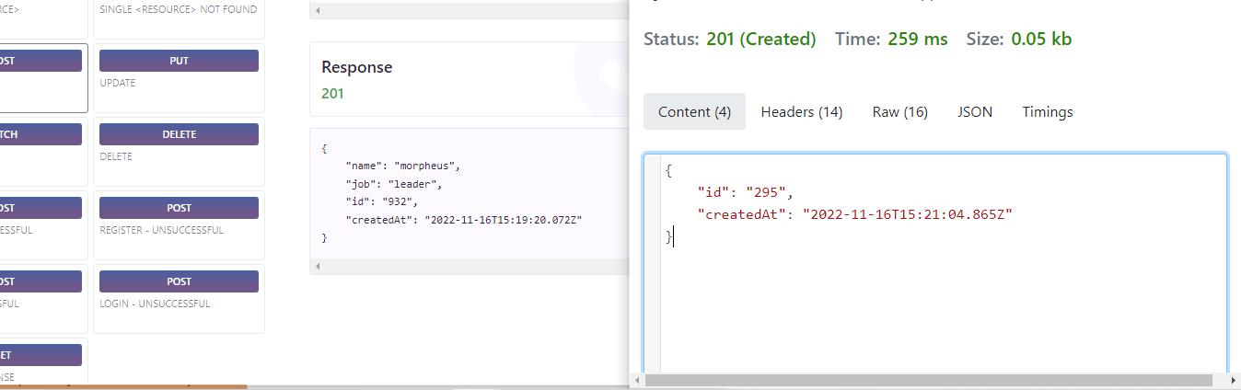

* UPDATE (PUT)

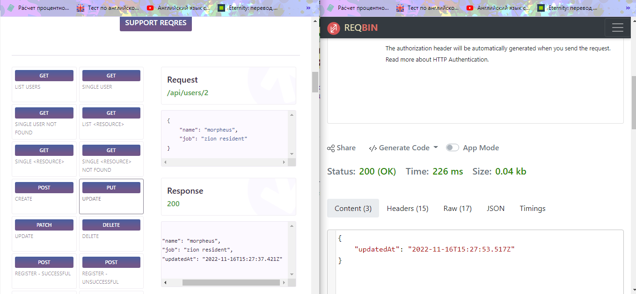

* UPDATE (PATCH)

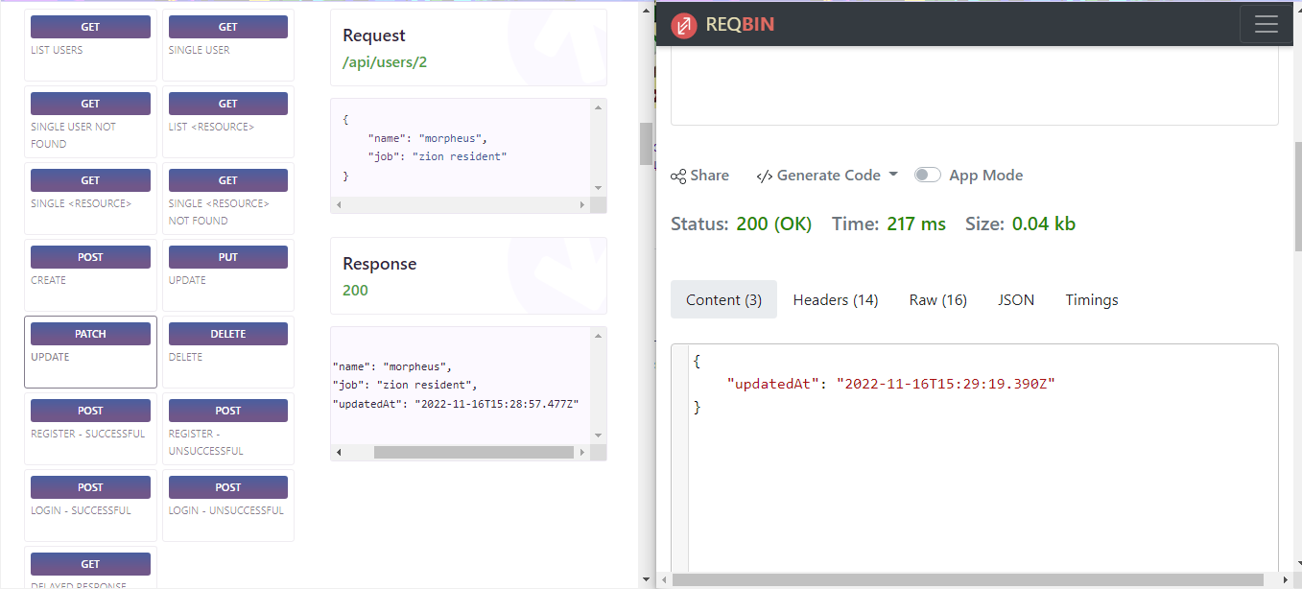

* DELETE

all right

* REGISTER - SUCCESSFUL

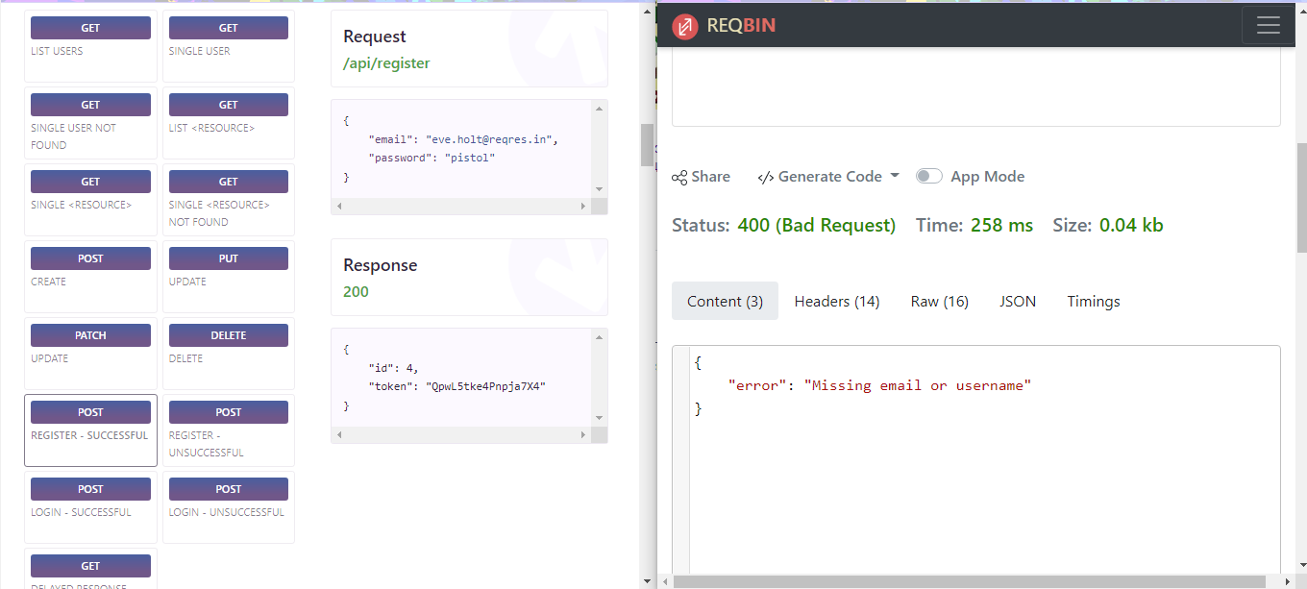

* LOGIN - SUCCESSFUL

